Name: ____________________________________________________________ Period: _________
Flowers for Algernon, by Daniel Keyes: Literature book pages190-215
Try to define each bold word using the context of the sentence.
1. The doctor knew he had done well but receiving an actual medal made his success more tangible.
The flag is a tangible representation of our freedom.
Tangible means:
Other forms of this word include:
2. He’s an opportunist because he’ll do anything to get ahead in his career.
The woman was an opportunist went around the slow driver to be next in line to be next in line at Starbucks.
Opportunist means:
Other forms of this word include:
3. The doctor had a specialization in brain development.
Mr. Smartpants was a good reading and civics teacher but his specialization was teaching science.
Specialization means:
Other forms of this word include:
4. The research findings created a sensation at the conference. Miss Lewis’s dance moves were quite the sensation at the school dance and everyone recording them on their phones so they could go home and learn them later.
Sensation means:
5. Will you refute the results, or do you believe them, too?
He had to refute what his teacher said because he knew the answer was not correct.
Refute means:
Other forms of this word include:
6. His understanding is proportional to his intelligence.
If Mrs. Blanchard’s bank account was proportional to the number of times she repeated directions, she would be rich.
Proportional means:
Other forms of this word include:

7. His long hours could impair his social life.
Drinking too much coffee might give you the jitters and impair your ability to stay focused.
Impair means:
Other forms of this word include:

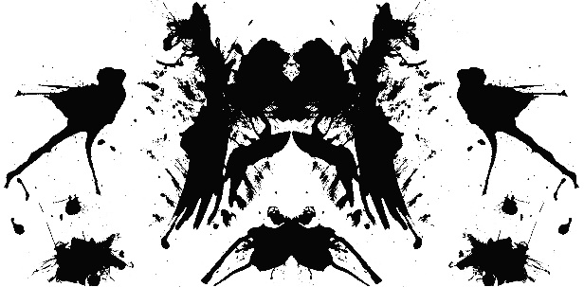
Look at the image on the right. What might this be? What do you see on this card? People see all sorts of things in these inkblots. What might it be for you—what does it make you think of?

Flowers for Algernon, page 190
This story is told in the form of journal entries or progress reports. You will notice that Charlie has a very unique style of writing and it plays an important part of the tory. Follow along in your book as you listen to the audio.
progris riport 1—martch 5 1965
What can you infer about Charlie Gordon based on his 1st progress report? What text evidence helped you form this inference?

progris riport 2—martch 6
Describe the test Charlie took. Explain why he didn’t pass the test.

progris report 3—martch 7
What do lines 41-46 tell you about Charlie’s desire to change?

Describe the Thematic Apperception Test. Explain why Charlie did not pass this test.

Who is Algernon in the story? What role does he plan in the story?

progris riport 4—Mar 8
What can you infer about why Charlie put asterisks (**) in some of his words when he writes?

What experiment is Charlie going to go through with Dr. Nemur and Dr. Strauss? If the experiment works, what will the outcome be?

Look at lines 100-103. Why does Dr. Strauss think Charlie is a good candidate for the experiment?

Progris ript 5—Mar 10 through Progress Report 7—mar 19
In what ways is the March 19 report different from the other reports so far? Think about its length and language.

Progress Report 8—Mar 23 through March 25
Why does Charlie think Joe Carp and Frank Reilly are his friends?

As a reader, what are your 1st impressions of Joe and Frank? Explain your thinking.

March 28 through Progress Report 9—April 3
Draw an illustration of the party at Muggsy’s Saloon. Then write a short summary of the event.

Summary of the event:
April 6 through April 15
List 3 pieces of evidence that proves Charlie is becoming smarter:
1.
2.
3.
Look at (m) in the text. Why do you think Miss Kinnian reacts the way she does?

